Farmers Registration

* On Clicking the link a new page is opened.
* This Page asks for Aadhar Card Number of the farmer and also requires captcha for confirming it as a human.

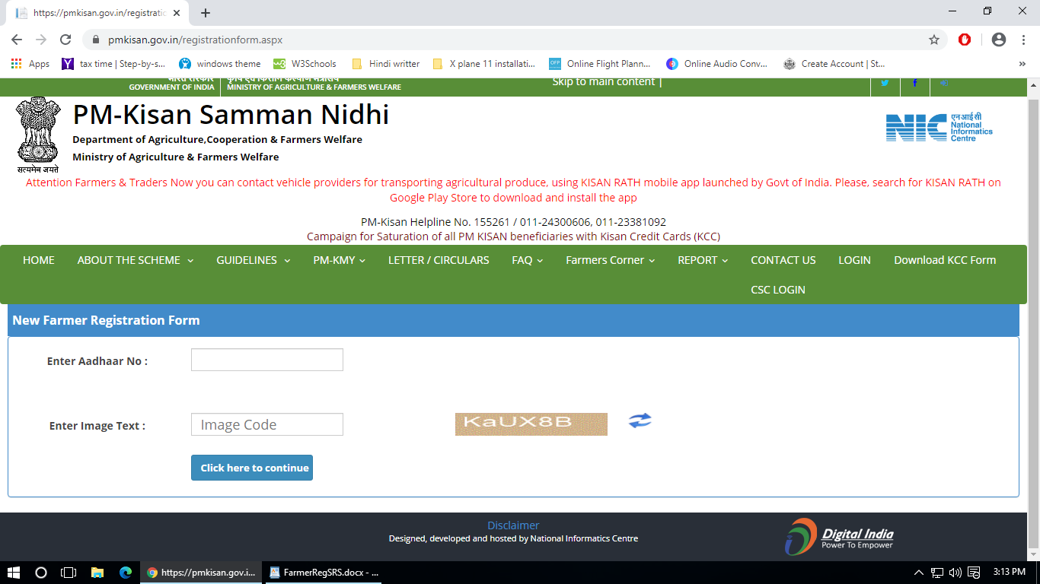

* For reference follow this link : <https://pmkisan.gov.in/RegistrationForm.aspx>
* After entering the above prerequisites, the button will redirect the user to the form page which will be as follows:

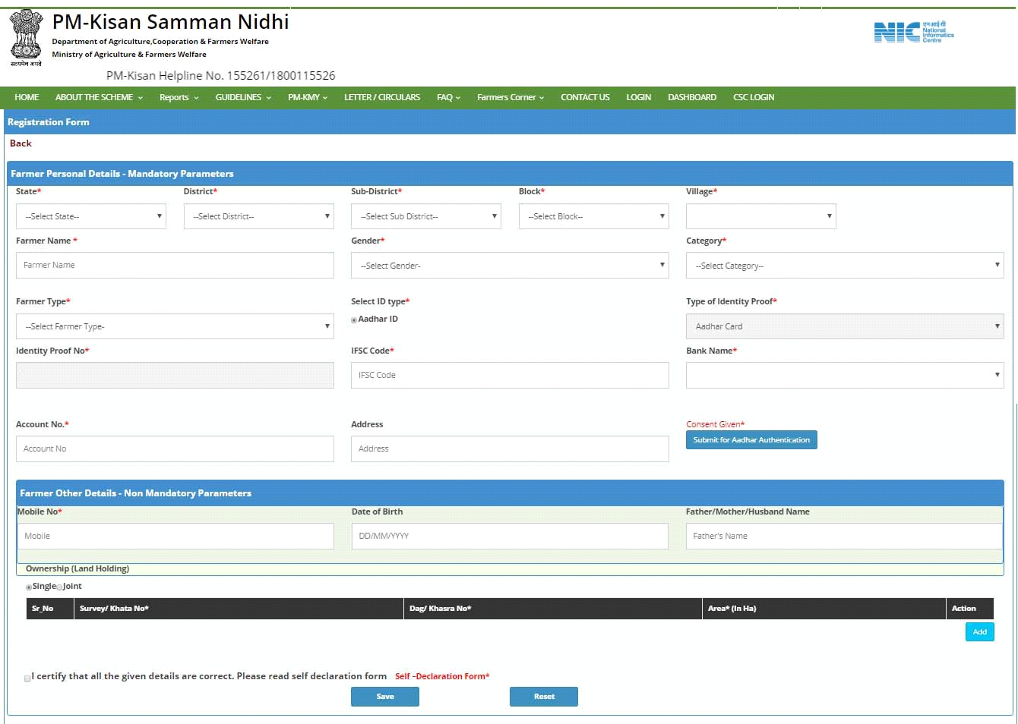

* Details may include the following:
* Farmer's name
* Gender
* Aadhar ID
* Address
* State
* District
* Sub-district
* Block
* Village
* Category
* Land (in hectares)
* Crop Names
* Crop 1
* Crop 2
* Crop n
* Personal Details
* Mobile Number
* Permanent Address
* Date of Birth